**Ajax**

AJAX is an acronym for **Asynchronous JavaScript and XML**. It is a group of inter-related technologies like JavaScript, DOM, XML, HTML, CSS etc.

AJAX is not a programming language. AJAX is an art to exchange data between client and server in background.

AJAX allows you to send and receive data asynchronously without reloading the web page. So it is fast.

AJAX allows you to send only important information to the server not the entire page. So only valuable data from the client side is routed to the server side. It makes your application interactive and faster.

Where it is used?

There are too many web applications running on the web that are using ajax technology like **gmail**, **facebook**,**twitter**,**google map**, **youtube** etc.

## How AJAX Works

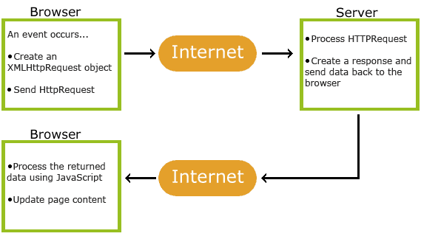

1. An event occurs in a web page (the page is loaded, a button is clicked)

* 2. An XMLHttpRequest object is created by JavaScript
* 3. The XMLHttpRequest object sends a request to a web server
* 4. The server processes the request
* 5. The server sends a response back to the web page
* 6. The response is read by JavaScript
* 7. Proper action (like page update) is performed by JavaScript

# Understanding XMLHttpRequest

An object of XMLHttpRequest is used for asynchronous communication between client and server.

It performs following operations:

1. Sends data from the client in the background
2. Receives the data from the server
3. Updates the webpage without reloading it.

## Properties of XMLHttpRequest object

The common properties of XMLHttpRequest object are as follows:

|  |  |
| --- | --- |
| **Property** | **Description** |
| onreadystatechange | It is called whenever readystate attribute changes. It must not be used with synchronous requests. |
| readyState | represents the state of the request. It ranges from 0 to 4.  **0** UNOPENED open() is not called.  **1** OPENED open is called but send() is not called.  **2** HEADERS_RECEIVED send() is called, and headers and status are available.  **3** LOADING Downloading data; responseText holds the data.  **4** DONE The operation is completed fully. |
| reponseText | returns response as text. |
| responseXML | returns response as XML |

Method of XMLHttpRequest

open()

send()

check.php

<?php

$a=$_GET[‘em’];

If($a==[as@yahoo.com](mailto:as@yahoo.com))

echo “Email Exist choose another”;

else

echo “Correct”;

?>

Reg.html

**<head>**

**<script>**

**varreq;**

**functiondisp()**

**{**

**var p=F.e1.value;**

**req=new XMLHttpRequest();**

**req.open("GET","check.php?em="+p,true);**

**req.send();**

**req.onreadystatechange=function()**

**{**

**if(req.readyState==4)**

**document.getElementById("r").innerHTML=req.responseText;**

**}**

**}**

**</script>**

**</head>**

**<body>**

**<form name="F" action="Register.php" method="post">**

**Name<input type="text" name="t1"><br>**

**Email<input type="text" name="e1" onblur="disp()"><span**

**id="r"></span><br>**

**Password <input type="password" name="p1"><br>**

**-**

**-**

**-**

**<input type="submit" value="Register Now">**

**</form>**

**</body>**